# PROJECT REPORT ON WEBHING DETECTION

# BY THE STUDENTS OF

# RMK. COLLEGE OF ENGINEERING AND TECHNOLOGY,PUDUVOYAL -601206

# MENTOR

# Mr. R. VIJAY ANANDH

# TEAM LEADER: SURIYAA.BK

# TEAM MEMBERS:

# 1) SAI KIRAN .KR

# 2) SANTHOSH. S

# 3) YOUVANESH S

# 

**TABLE OF CONTENTS**

**1. INTRODUCTION 3**

|  |  |
| --- | --- |
| 1.1. Project Overview | 3 |
| 1.2. Purpose | 3 |
| **2. LITERATURE SURVEY** | **4** |
| 2.1. Existing problem | 4 |
| 2.2. References | 4 |
| 2.3. Problem Statement Deﬁnition | 5 |
| **3. IDEATION & PROPOSED SOLUTION** | **6** |
| 3.1. Empathy Map Canvas | 6 |
| 3.2. Ideation & Brainstorming | 7 |
| 3.3. Proposed Solution | 8 |
| 3.4. Problem Solution ﬁt | 9 |
| **4. REQUIREMENT ANALYSIS** | **10** |
| 4.1. Functional requirement | 10 |
| 4.2. Non-Functional requirements | 10 |
| **5. PROJECT DESIGN** | **13** |
| 5.1. Data Flow Diagrams | 13 |
| 5.2. Solution & Technical Architecture | 13 |
| 5.3. User Stories | 16 |
| **6. PROJECT PLANNING & SCHEDULING** | **17** |
| 6.1. Sprint Planning & Estimation | 17 |
| 6.2. Sprint Delivery Schedule | 17 |
| 6.3. Reports from JVIRA | 18 |
| **7. ODING & SOLUTIONING** | **18** |
| 7.1. Feature 1 | 18 |
| 7.2. Feature 2 | 20 |
| 7.3. Database Schema | 21 |
| **8. TESTING** | **22** |
| 8.1. Test Cases | 22 |
| 8.2. User Acceptance Testing | 23 |
| **9. RESULTS** | **28** |
| 9.1. Performance Metrics | 24 |
| **10. ADVANTAGES & DISADVANTAGES** | **25** |
| **11. CONCLUSION** | **26** |
| **12. FUTURE SCOPE** | **26** |
| **13. APPENDIX** | **27** |
| 13.1. Source Code | 27 |
| 13.2. GitHub & Project Demo Link | 27 |

1. **INTRODUCTION**
   1. **Project Overview**

Phishing is a form of the attacker tries to learn sensitive information such as login credentials or account information by sending as a reputable entity or person in email or other communication channels.Typically a victim receives a message that appears to have been sent by a known contact or organization. The message contains malicious software targeting the user’s computer or has links to direct victims to malicious websites in order to trick them into divulging personal and financial information, such as passwords, account IDs or credit card details.Phishing is popular among attackers, since it is easier to trick someone into clicking a malicious link which seems legitimate than trying to break through a computer’s defense

## 1.2 PURPOSE

We have developed our project using a website as a platform for all the users. This is an interactive and responsive website that will be used to detect whether a website is legitimate or phishing. This website is made using different web designing languages which include HTML, CSS, JavaScript and Django.

The basic structure of the website is made with the help of HTML. CSS is used to add effects to the website and make it more attractive and user-friendly. It must be noted that the website is created for all users, hence it must be easy to operate with and no user should face any difficulty while making its use. Every naive person must be able to use this website and avail maximum benefits from it.

The website shows information regarding the services provided by us. It also contains information regarding ill- practices occurring in todays technological world. The website is created with an opinion such that people are not only able to distinguish between legitimate and fraudulent website, but also become aware of the mal-practices occurring in current world. They can stay away from the people trying to exploit ones personal information, like email address, password, debit card numbers, credit card details, CVV, bank account numbers, and the list goes on.

The dataset consists of different features that are to be taken into consideration while determining a website URL as legitimate or phishing.

## LITERATURE SURVEY

* 1. **Existing problem**

Phishing is a technique used by hackers to fool internet users reveal their sensitive information like passwords, credit card numbers, contact information, and address, etc. Web phishing is carried out mostly by sending fake web links to the users through different communication means like Email, Facebook Messenger and WhatsApp, etc. Web phishing detection is signiﬁcant for making internet browsing safe and secure for users. Different approaches were applied for the detection of fake websites. However, the most eﬃcient method for detecting

phishing websites is the one that is based on artiﬁcial intelligence and learning mechanism. In this research, an eﬃcient and accurate method is proposed for the detection of phishing websites which is based on computational intelligence. Through the development of different computational models and rigorous testing, it was revealed that Extreme Gradient Boost

(XGBoost) based model achieved the maximum scores in all the validation tests. This shows that the model is robust and accurate in terms of web-phishing detection.

* 1. **References**

a

* + 1. J. Shad and S. Sharma, A Novel Machine Learning Approach to Detect Phishing Websites Jaypee Institute of Information Technology, pp. 425430, 2018.
    2. Y. Sönmez, T. Tuncer, H. Gaskell, and E. Avci, Phishing web sites features classification based on extreme learning machine, 6th Int. Symp. Digit. Forensic Secure. ISDFS 2018 – Proceeding, vol. 2018 January, pp. 15, 2018.
    3. T. Peng, I. Harris, and Y. Sawai, Detecting Phishing Attacks Using Natural Language Processing and Machine Learning, Proc. – 12th IEEE Int. Conf. Semant. Compute. ICSC 2018, vol. 2018Janua, pp. 300301, 2018.
    4. M. Karabatan and T. Mustafa, Performance comparison of classifiers on reduced phishing website dataset, 6th Int. Symp. Digit. Forensic Secure. ISDFS 2018 – Proceeding, vol. 2018Janua, pp. 15, 2018.
    5. S. Parekh, D. Parikh, S. Kotak, and P. S. Sankhe, A New Method for Detection of Phishing Websites: URL Detection, in 2018 Second International Conference on Inventive Communication and Computational Technologies (ICICCT), 2018, vol. 0, no. Icicct, pp. 949952.
    6. K. Shima et al., Classification of URL bitstreams using bag of bytes, in 2018 21st Conference on Innovation in Clouds, Internet and Networks and Workshops (ICIN), 2018, vol. 91, pp. 15.
    7. W. Fadhil, M. Abusharkh, and I. Abdel-Qader, On Feature Selection for the Prediction of Phishing Websites, 2017 IEEE 15th Intl Conf Dependable, Auton. Secure. Compute. 15th Intl Conf Pervasive Intel. Compute. 3rd Intl Conf Big Data Intell. Comput. Cyber Sci. Technol. Conger., pp. 871876, 2017.
    8. X. Zhang, Y. Zeng, X. Jinn, Z. Yan, and G. Geng, Boosting the Phishing Detection Performance by Semantic Analysis, 2017.
    9. L. MacHado and J. Gadge, Phishing Sites Detection Based on C4.5 Decision Tree Algorithm, in 2017 International Conference on Computing, Communication, Control and Automation, ICCUBEA 2017, 2018, pp. 15.
    10. A. Desai, J. Jatakia, R. Naik, and N. Raul, Malicious web content detection using machine leaning, RTEICT 2017 – 2nd IEEE Int. Conf. Recent Trends Electron. Inf. Commun. Technol. Proc., vol. 2018Janua, pp. 14321436, 2018.
  1. **Problem Statement Deﬁnition**

|  |  |  |  |
| --- | --- | --- | --- |
| **Problem Statemen t (PS)** | **I am** | **I’m trying to** | **But** |
| **PS-1** | Internet user | **Browse the internet** | **I identify a scam.** |
| **PS-2** | Enterprise r  user | **Open emails in the cloud server** | **I detect malicious protocols** |

**Problem Statement (PS)**

There are e-banking websites that requests the users to provide more sensitive information such as credit card details, password etc., for malicious reasons. These websites that mimics trustful URLs and webpages are known as phishing websites. Common causes for web phishing attacks involve:

• Users lack of security awareness

• Not performing sufficient due diligence

• Low-cost phishing and ransomware tools are easy to get hold of

• Malware is becoming more sophisticated and so on Web phishing is considered to be a threat in various aspects of security on the internet, which might involve scams and private information disclosure. Some of the common threats of web phishing are:

• Attempt to fraudulently solicit personal information from an individual or organization

. • Attempt to deliver malicious software by posing as a trustworthy organisation or entity.

• Installing those malwares infects the data that cause a data breach or even nature’s forces that takes down your company’s data headquarters, disrupting access. For this purpose, the objective of our project involves building an efficient and intelligent system to detect such websites by applying a machine-learning algorithm which implements classification algorithms and techniques to extract the phishing datasets criteria to classify their legitimacy and as a result of which whenever a user makes a transaction online and makes payment through an ebanking website our system will use a data mining algorithm to detect whether the e-banking website is a phishing website or not. This project can be further extended by creating a browser extension or develop a GUI which takes the URL and analyse its nature to determine if it is a legitimate or a phishing website.

## IDEATION & PROPOSED SOLUTION

* 1. **EMPATHY MAP**

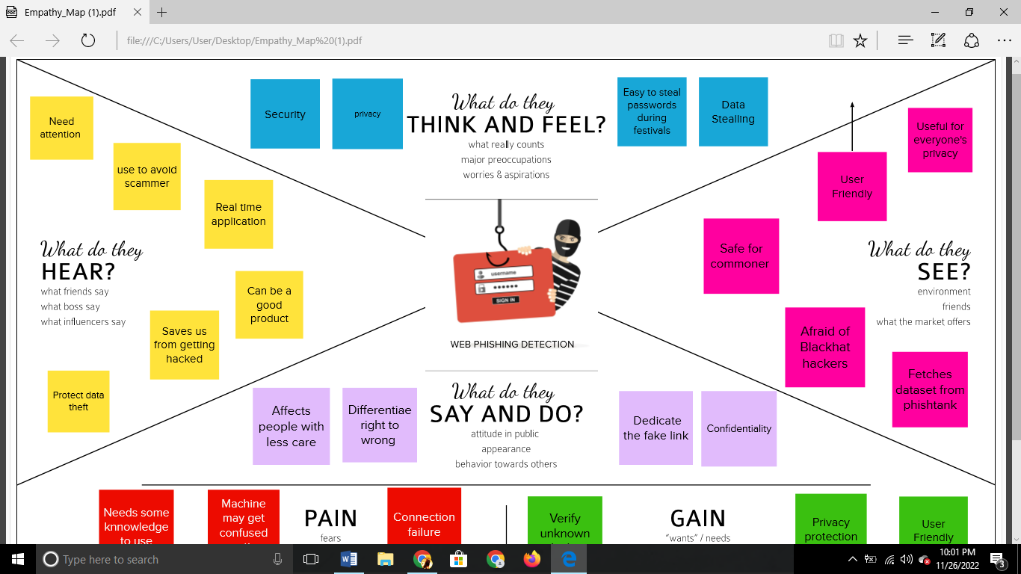

* 1. **Ideation & Brainstorming**

**PRIORITIZE CHART:**

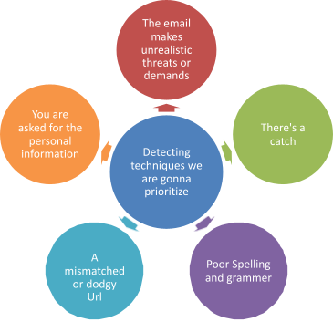

* 1. **Proposed Solution**

1. **Problem Statement (Problem to be solved)**

Web phishing tends to steal a lots of information from the user during online transaction like username, password, important documents that has been attached to that websites. There are Multiple Types of Attacks happens here every day, but there is no auto detection Process through Machine Learning is achieved

1. **Idea / Solution description**

Through ML and data mining techniques like classiﬁcation algorithm user can able to attain a warning signal to notify these phishing websites which helps the user to safeguard their identities and their login credentials etc. python is thelanguage that helps to enable these techniques for the online users.

1. **Novelty / Uniqueness**

This project not only able to identify the malicious websites it also has the ability to automatically block these kind of websites completely in the future when it has been identiﬁed and also blocks some various mails /ads from these malicious websites

1. **Social Impact / Customer Satisfaction**

This web phishing detection project attains the customer satisfaction by discarding variouskinds of malicious websites to protect their privacy. This project is not only capable of using by an single individual ,a large social community and a organisation can use this web phishing detection to protect their privacy. This project helps to block various malicious websites simultaneously.

1. **Business Model (Revenue Model)**

This developed model can be used as an enterprise applications by organisations which handles sensitive information and also can be sold to government agencies to prevent the loss of potential important data.

This project is not only capable of using by an single individual ,a large social community and a organisation can use this web phishing detection to protect their privacy. This project helps to block various malicious websites simultaneously.

1. **Scalability of the Solution**

This project is not only capable of using by an single individual ,a large social community and a organisation can use this web phishing detection to protect their privacy. This project helps to block various malicious websites simultaneously.

* 1. **Problem Solution ﬁt**

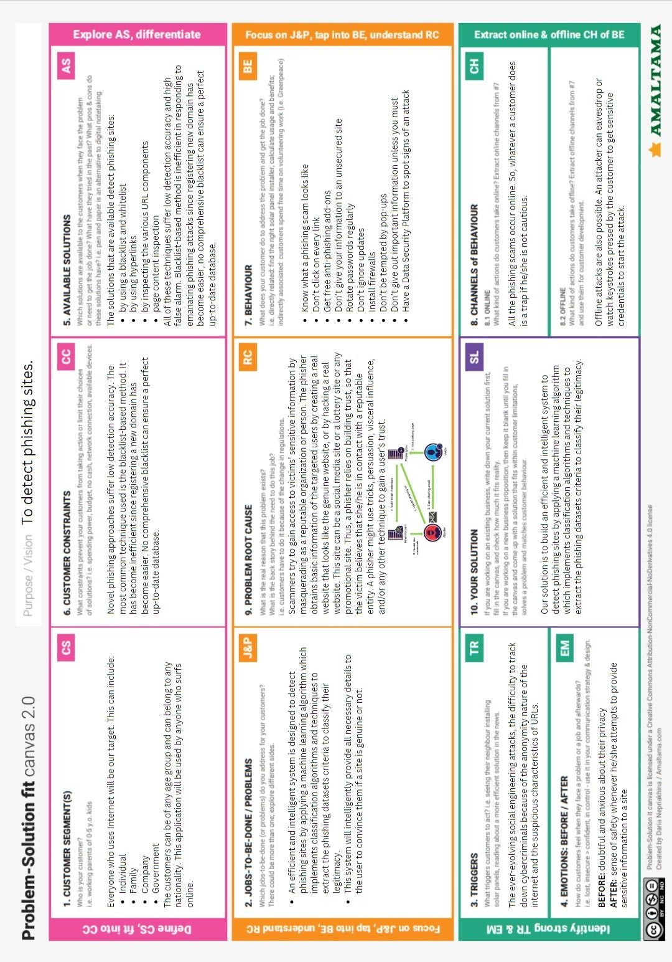

## REQUIREMENT ANALYSIS

* 1. **Functional Requirements:**

Following are the functional requirements of the proposed solution.

|  |  |  |
| --- | --- | --- |
| **FR NO.** | **Functional**  **Requirement (Epic)** | **Sub Requirement (Story / Sub-Task)** |
| FR-1 | User Input | User inputs an URL in required field to check its validation. |
| FR-2 | Website Comparison | Model compares the websites using Blacklist and White list approach. |
| FR-3 | Feature extraction | After comparing, if none found on comparison then it extracts feature using heuristic and visual similarity approach. |
| FR-4 | Prediction | Model predicts the URL using Machine  Learning algorithms such as Logistic Regression, KNN |
| FR-5 | Classifier | Model sends all output to classifier and produces final result. |
| FR-6 | Announcement | Model then displays whether website is a legal site or a phishing site. |
| FR-7 | Events | This model needs the capability of retrieving and displaying accurate result for a website |

## Non-functional Requirements:

Following are the non-functional requirements of the proposed solution.

|  |  |  |
| --- | --- | --- |
| **FR No.** | **Non-Functional Requirement** | **Description** |
| NFR-1 | **Usability** | We intend to evaluate important **usability** issues related to **fake website** detection systems, 11, 13 . User can access to several website easily using  web phishing detection without loosing any data |
| NFR-2 | **Security** | User can check whether the websites are secure or not by getting pop-up message. Phishing is most often seen in the form of malicious emails pretending to be from credible sources like  people, departments, or organizations related to the university. |
| NFR-3 | **Reliability** | The users should get availability to access the  resources must be valid and reliable |
| NFR-4 | **Performance** | **performance** (i.e. detection and false positive  rates) of the automated approaches. performance |

|  |  |  |
| --- | --- | --- |
|  |  | should be faster and user friendly for the effective  performance |
| NFR-5 | **Availability** | The users should get availability to access the  resources must be valid and reliable. |
| NFR-6 | **Scalability** | The performance of the website should be efficient to handle the increasing user and loads without any disturbance |

## PROJECT DESIGN

* + 1. **Data Flow Diagrams**

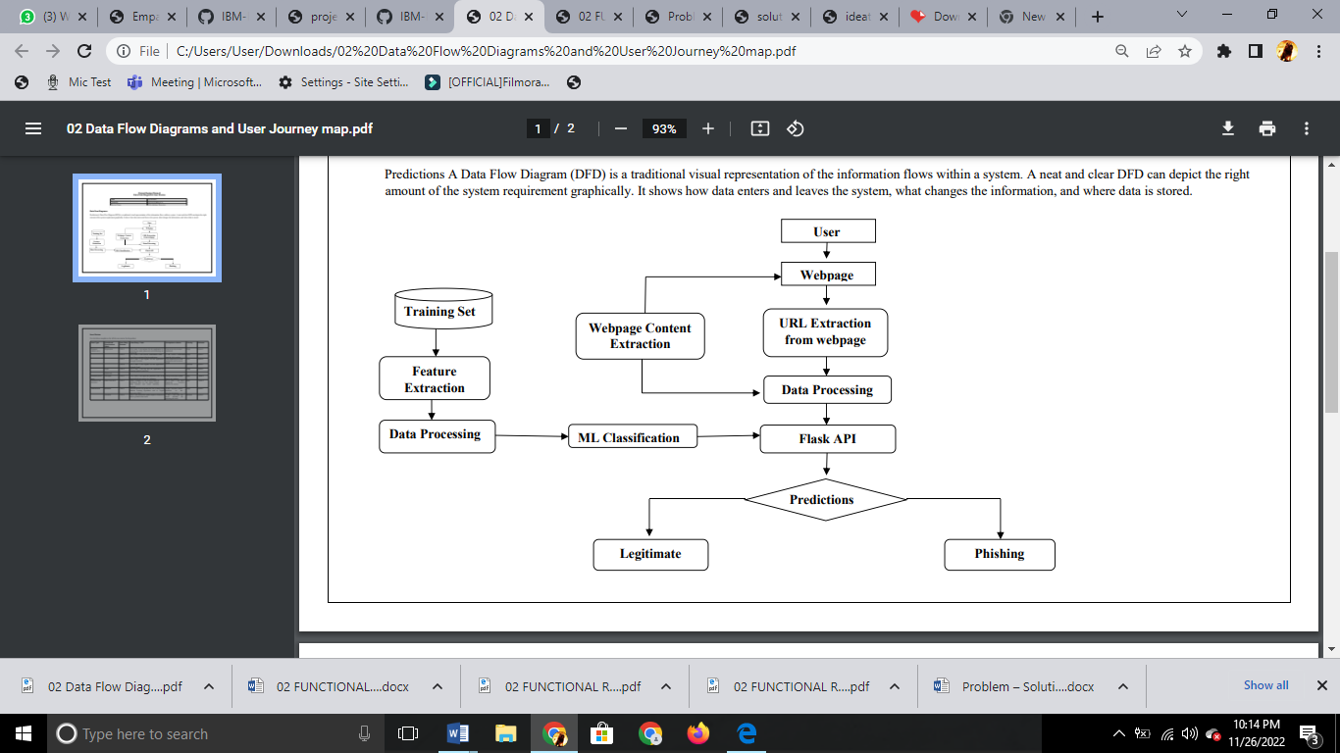

* + 1. **Solution & Technical Architecture Solution Architecture**

Solution architecture is a complex process – with many sub-processes – that bridges the gap between business problems and technology solutions.

Its goals are to:

* Find the best tech solution to solve existing business problems.
* Describe the structure, characteristics, behavior, and other aspects of the software to project stakeholders.
* Deﬁne features, development phases, and solution requirements.
* Provide speciﬁcations according to which the solution is deﬁned, managed, and delivered

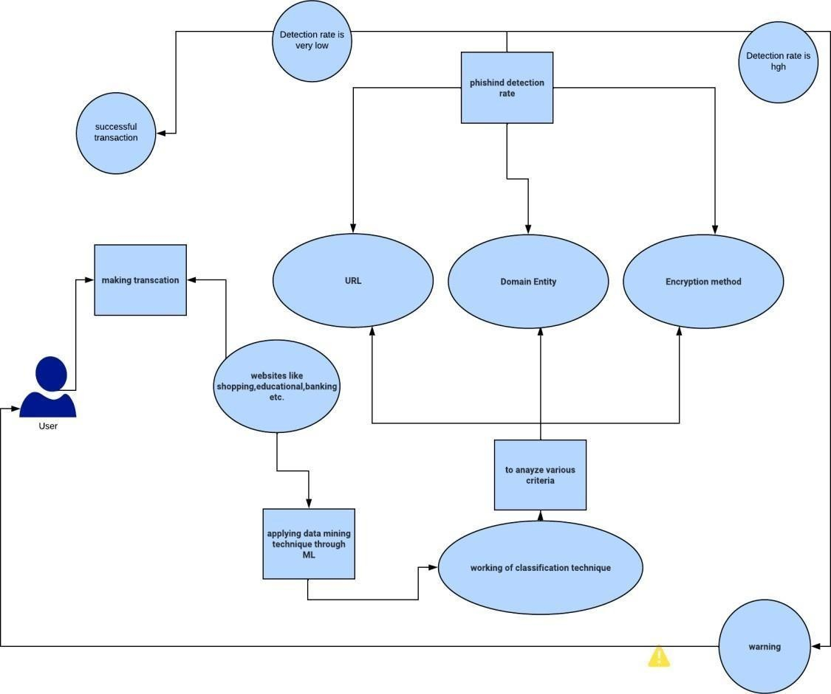

**Technical Architecture**

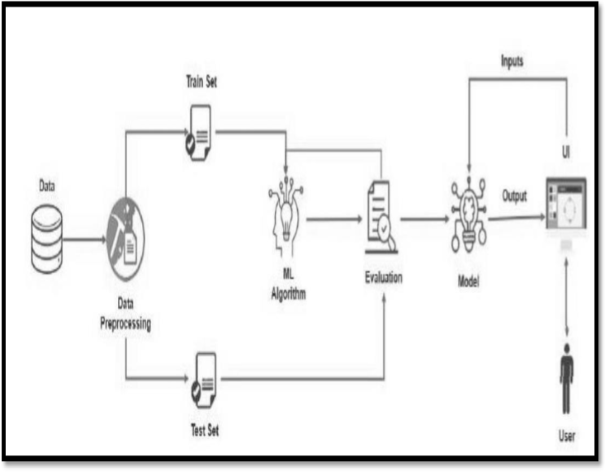

# User Stories

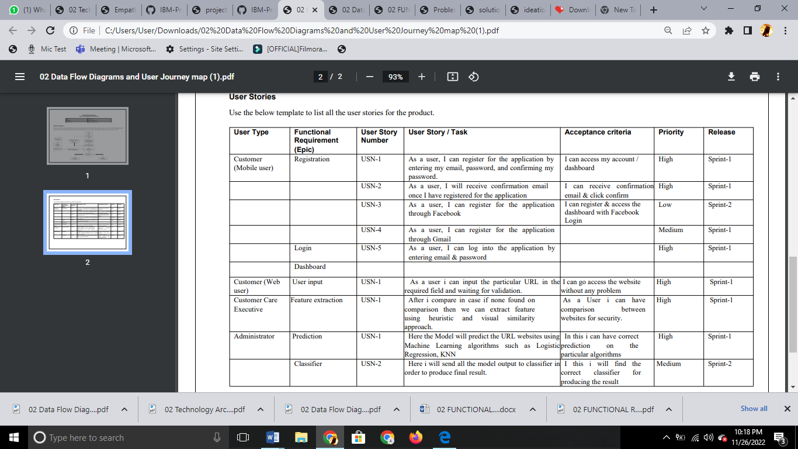

 

# PROJECT PLANNING &

**SCHEDULING**

## SPRINT PLANNING & ESTIMATION

## 

## REPORT FROM JIRA

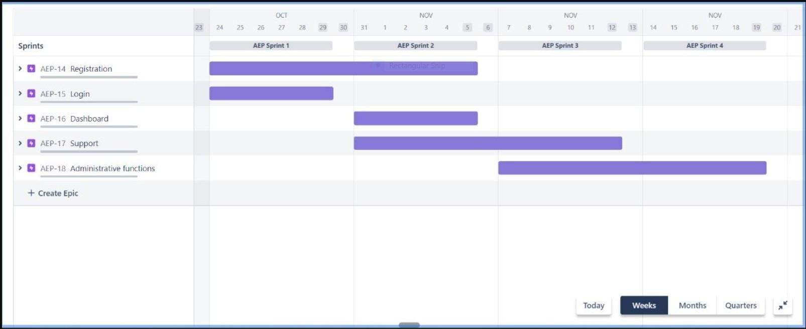

* 1. **CODING & SOLUTIONING**
     1. **Feature 1**
        + Analyzed university admission statistics
        + Developed tools for matching university (in percentile) using CGPA,GRE (Verbal, Quantitative, Analytical Writing) scores
        + Languages : Python
        + Tools/IDE : Anaconda(Jupyter notebook)
        + Libraries : Recommendation

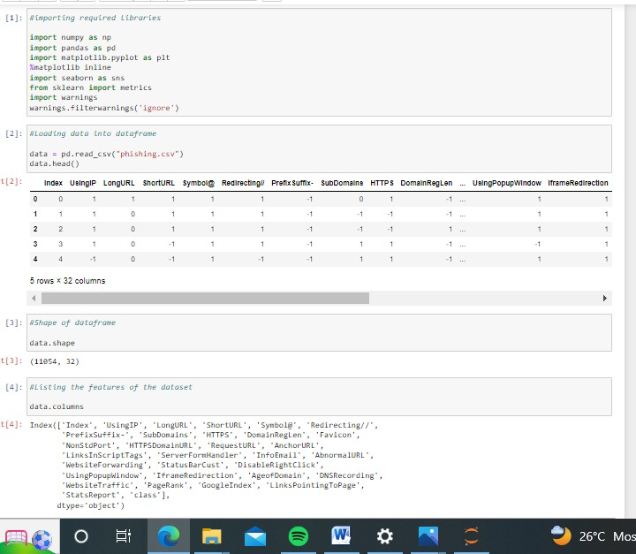

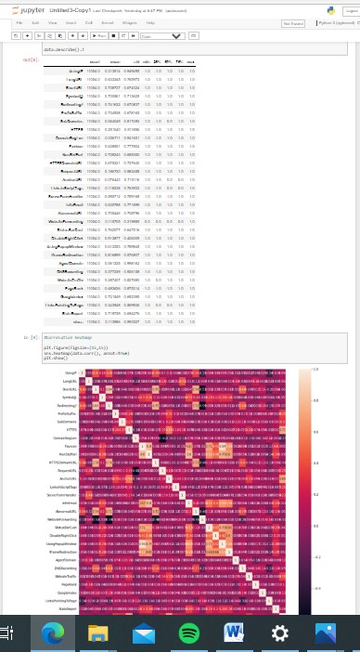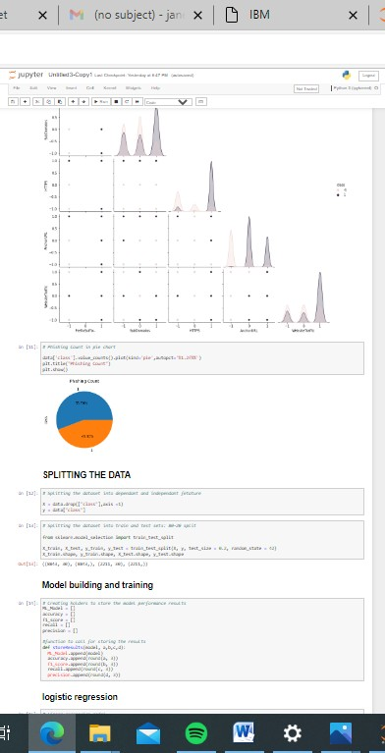

* + 1. **Feature 2**

**Index**

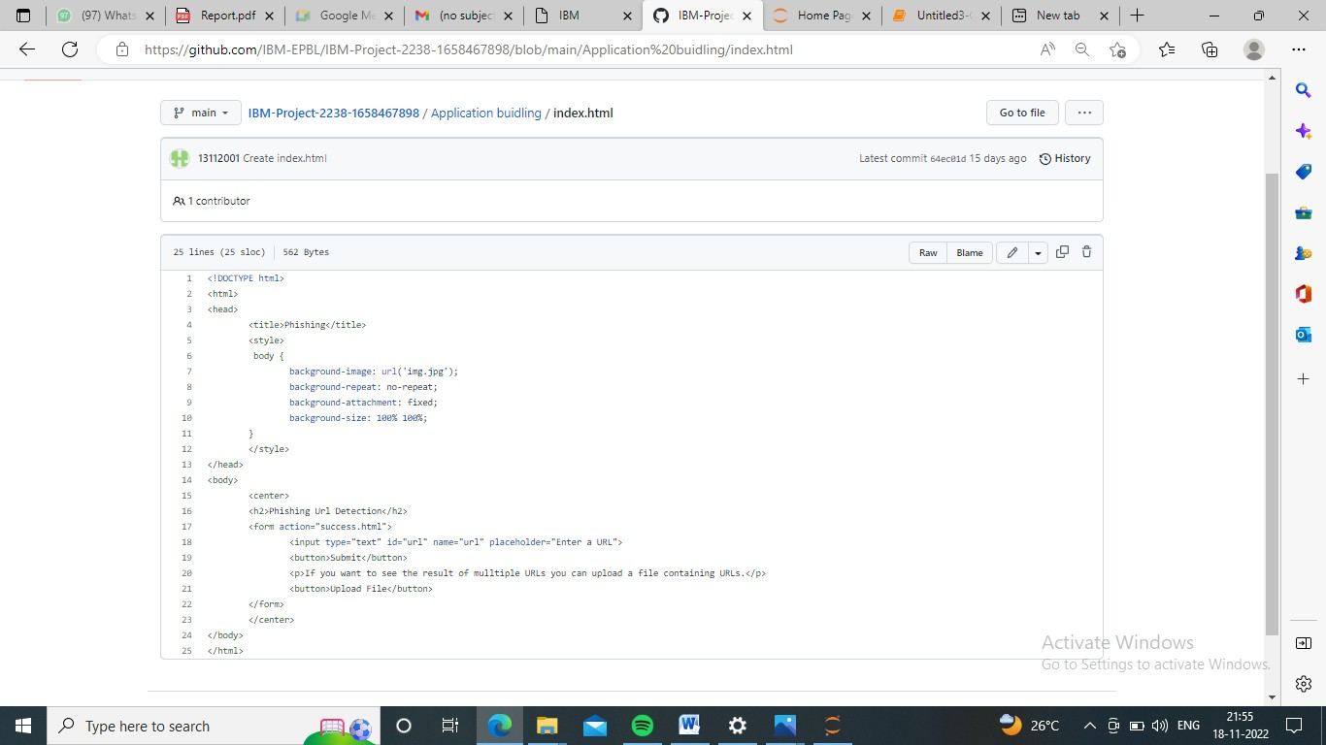

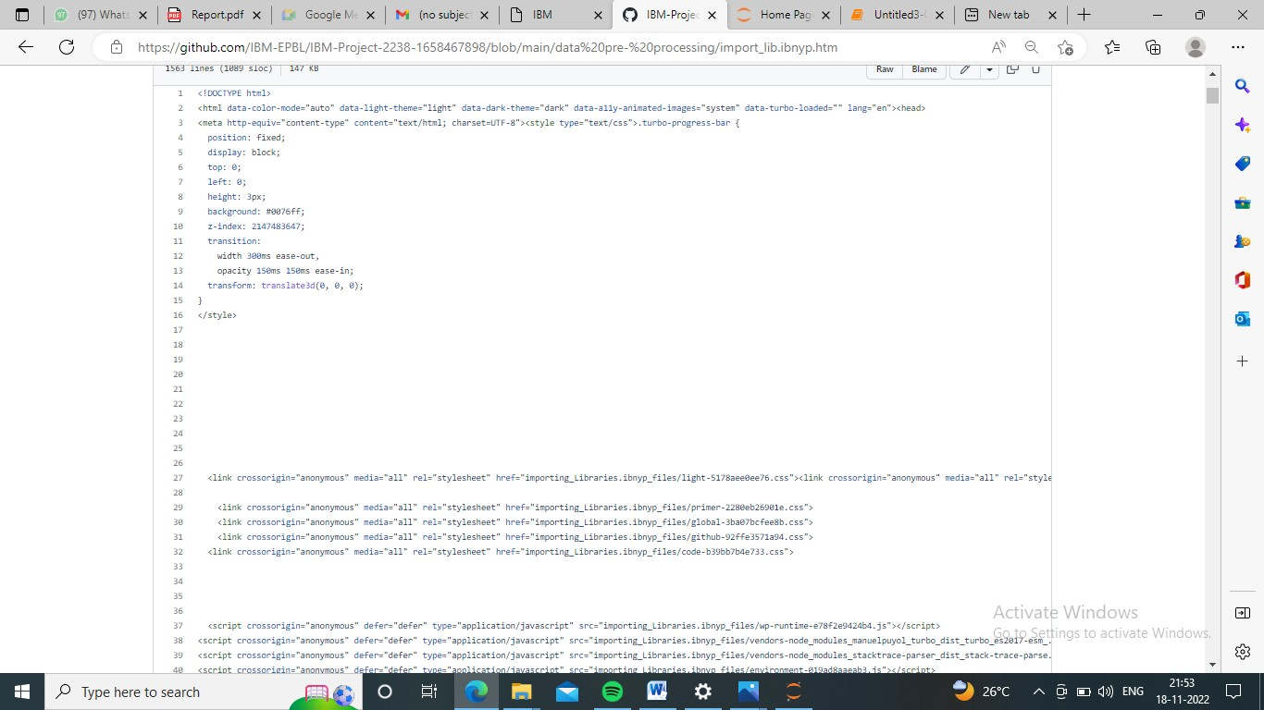

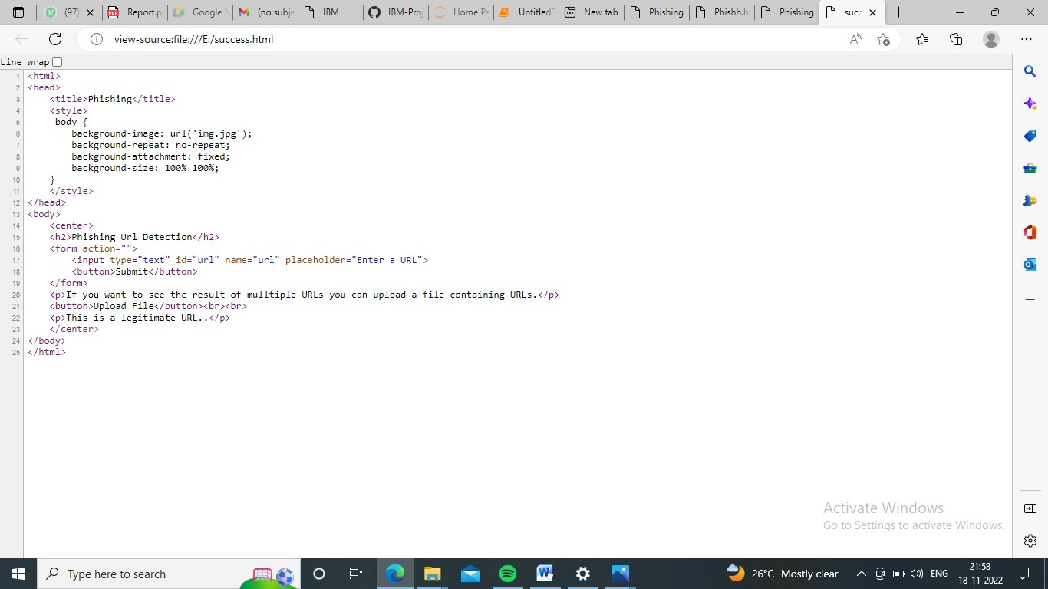**Chance**

* + 1. **Database Schema**

## TESTING

* 1. **Test Cases**

**Feature Type**

**Comtponen**

**Test Scenario**

**Pre-Requisite**

**Steps To Execute**

**Test Data**

**Expected Result**

**ARcestualtl**

**Status**

**Comments**

**A) utomTaCtifoonr(Y/N BIUDG**

**Executed By**

Lo Verify user is able to see the

Functional Home Landing Page when user can

1.Enter URL and click

go 2.Type the URL 3p.rVoceerisfsyinwghoerthneort.it is

https://phishing- shield.herokuapp.com/

Should Display the Webpage

Working as

Pass N Janet rajajothi

Page

type the URL in the box

expected

Lo UI Home Page

Verify the UI elements is Responsive

1. Enter URL and click go

2. Type or copy paste the URL

3. Check whether the button is responsive or not

4. Reload and Test Simultaneously

https://phishing- shield.herokuapp.com/

Should Wait for Response and then gets Acknowledge

Working as expected

Pass N Krithika

Lo Functional Home page

Verify whether the link is legitimate or not

1. Enter URL and click go

2. Type or copy paste the URL

3. Check the website is legitimate or not

4. Observe the results

https://phishing- shield.herokuapp.com/

User should observe whether the website is legitimate or not.

Working as expected

Pass N Keerthi

Lo Functional Home Verify user is able to access the

1. Enter URL and click go

2. Type or copy paste the URL

3. Check the website is legitimate

https://phishing-

Application should show that Safe Webpage or Unsafe.

Working

Pass N

Page

legitimate website or not

or not

4. Continue if the website is

legitimate or be cautious if it is

not legitimate.

shield.herokuapp.com/

as

expected

Chandhini

Lo Functional Home Page Testing the website with

1. Enter URL ( https://phishing- shield.herokuapp.com/) and click go

2. Type or copy paste the URL to test

1.

https:// sivanesan03.git hub.io

/welcome

User can able to identify the websites whether it is secure or not

Working

Pass N Keerthi

multiple URLs

3. Check the website is legitimate 3. http2s:./t[/](http://www.klnce.edu/)o[w](http://www.klnce.edu/)ta[w](http://www.klnce.edu/)lp[w](http://www.klnce.edu/)a[.](http://www.klnce.edu/)d[k](http://www.klnce.edu/).[l](http://www.klnce.edu/)c[n](http://www.klnce.edu/)o[c](http://www.klnce.edu/)m[e.edu](http://www.klnce.edu/)

or not

as

expected

4. Continue if the website is

https:6/[/.wdwelwge.gtso.ocgolme.com/](http://www.google.com/)

salescript.info 5.

secure or be cautious if it is not 4.

secure

* 1. **User Acceptance Testing**

## Purpose of Document

The purpose of this document is to brieﬂy explain the test coverage and open issues of the [Web Phishing Detection] project at the time of the release to User Acceptance Testing (UAT).

## Defect Analysis

This report shows the number of resolved or closed bugs at each severity level, and how they were resolved

|  |  |  |  |  |  |
| --- | --- | --- | --- | --- | --- |
| **Resolution** | **Severity 1** | **Severity 2** | **Severity 3** | **Severity 4** | **Subtotal** |
| By Design | 10 | 4 | 2 | 3 | 20 |
| Duplicate | 1 | 0 | 3 | 0 | 4 |
| External | 2 | 3 | 0 | 1 | 6 |
| Fixed | 10 | 2 | 4 | 20 | 36 |
| Not Reproduced | 0 | 0 | 1 | 0 | 1 |
| Skipped | 0 | 0 | 0 | 0 | 0 |
| Won't Fix | 0 | 0 | 2 | 1 | 3 |
| Totals | 23 | 9 | 12 | 25 | 60 |

## Test Case Analysis

This report shows the number of test cases that have passed, failed, and untested

|  |  |  |  |  |
| --- | --- | --- | --- | --- |
| **Section** | **Total Cases** | **Not Tested** | **Fail** | **Pass** |
| Print Engine | 10 | 0 | 0 | 10 |
| Client Application | 50 | 0 | 0 | 50 |
| Security | 5 | 0 | 0 | 4 |
| Outsource Shipping | 3 | 0 | 0 | 3 |
| Exception Reporting | 10 | 0 | 0 | 9 |
| Final Report Output | 10 | 0 | 0 | 10 |
| Version Control | 4 | 0 | 0 | 4 |

## RESULTS

* 1. **Performance Metrics**

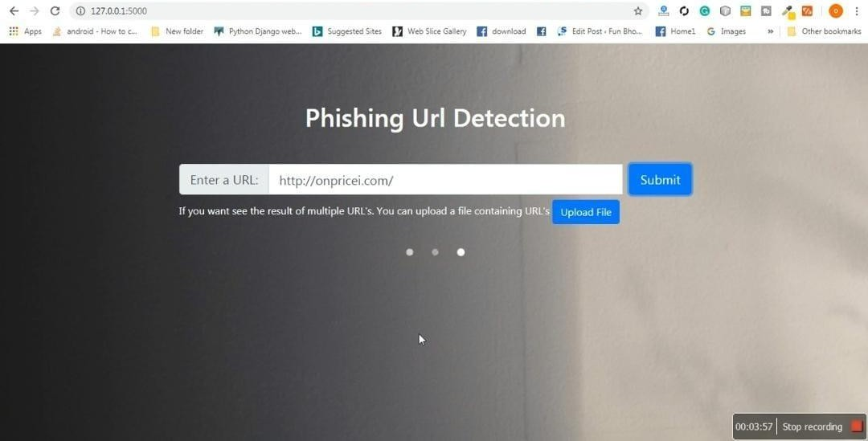

Time consuming huge number of features consuming Consuming memory non standard classiﬁer

Time consuming because this technique has many layers to make the ﬁnal results

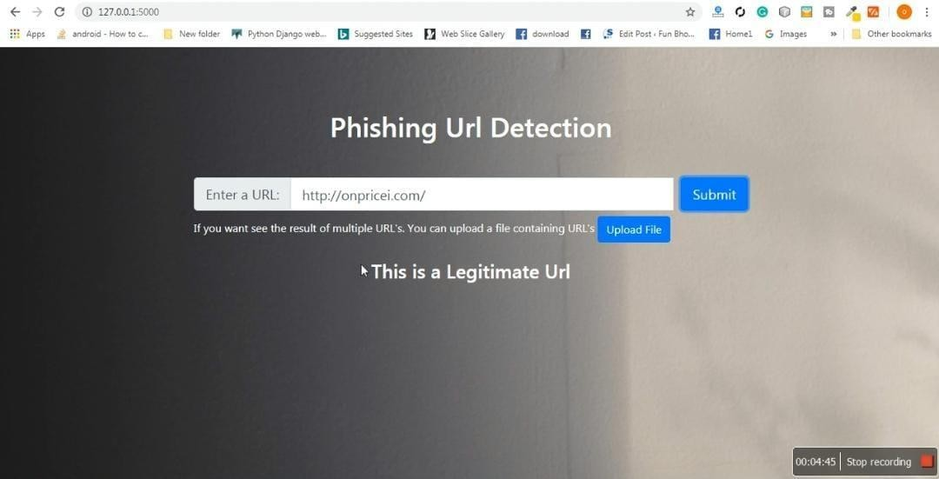

**10 ADVANTAGES**

Methods based on bag of words ,build secure connection between user’s mail transfer agent(MTA) and mail user agent(MUA)

Provide clear idea about the effective algorithms provide clear idea about the effective level of each classiﬁer on phishing email detection.

Hybrid system high level accuracy by take the advantages of many classiﬁers

Classiﬁers model based features high level of accuracy create new type of features like markov features.

Clustering of phishing email fast in classiﬁcation process.

**DISADVANTAGES**

Time consuming huge number of features consuming Consuming memory non standard classiﬁer

Time consuming because this technique has many layers to make the ﬁnal results

Huge number of features many algorithm for classiﬁcation which mean time consuming high cost.

Need feed continuously.

## 11 .CONCLUSION

***The proposed study emphasized the phishing technique in the context of classification, where phishing website is considered to involve automatic categorization of websites into a predetermined set of class values based on several features and the class variable. The ML based phishing techniques depend on website functionalities to gather information that can help classify websites for detecting phishing sites. The problem of phishing cannot be eradicated, nonetheless can be reduced by combating it in two ways, improving targeted anti-phishing procedures and techniques and informing the public on how fraudulent phishing websites can be detected and identified. To combat the ever evolving and complexity of phishing attacks and tactics, ML anti-phishing techniques are essential.***

***Authors employed LSTM technique to identify malicious and legitimate websites. A crawler was developed that crawled 7900 URLs from AlexaRank portal and also employed Phishtank dataset to measure the efficiency of the proposed URL detector. The outcome of this study***

***reveals that the proposed method presents superior results rather than the existing deep learning methods. A total of 7900 malicious URLS were detected using the proposed URL detector. It has achieved better accuracy and F1—score with limited amount of time. The future direction of this study is to develop an unsupervised deep learning method to generate insight from a URL. In addition, the study can be extended in order to generate an outcome for a larger network and protect the privacy of an individual.***

## FUTURE SCOPE

The future scope of this project is very broad. Few of them are:

* + Phishing is a considerable problem differs from the other security threats such as intrusions and Malware which are based on the technical security holes of the network systems. The weakness point of any network system is its Users.
  + Phishing attacks are targeting these users depending on the trikes of social engineering. Despite there are several ways to carry out these attacks, unfortunately the current phishing detection techniques cover some attack vectors like email and fake websites. Therefore, building a specific limited scope detection system will not provide complete protection from the wide phishing attack vectors.
  + This paper develops detection system with a wide protection scope using URL features only which is relying on the fact that users directly deal with URLs to surf the internet and provides a good approach to detect malicious URLs as proved by

previous studies. Additionally, Anti-phishing solutions can be positioned at different levels of attack flow where most researchers are focusing on client side solutions which turn to add more processing overhead at the client side and lead to losing the trust and satisfaction of the users

* + . Nowadays many organizations make centralized protection of spam filtering. This paper proposes a system which can be integrated into such process in order to increase the detection performance in a real time. The simulation results of the proposed system showed a phishing URLs detection accuracy with 93% and provided online process of a single URL in average time of 0.12 second.

.

## APPENDIX

* 1. **Source Code**

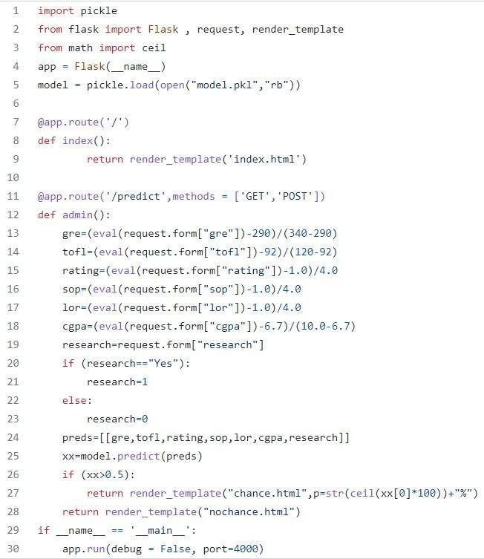

* 1. **Github & Project Demo Link**

**Github Link:**

**Project Demo Link:**